Executive Summary

This project aims to review the impact of region, year, age and gender on university acceptance. This project has value within the Apprentice’s industry, as it enables decision makers to identify and review patterns which impact university acceptance, and put necessary measures in place to support specific individuals who may be less likely to enter university.

Data Infrastructure & Tools

This project uses a range of tools to review the open-sourced data, including Power BI, Excel, and Python.

Firstly, the data was sourced from UCAS (UCAS, 2025). The data is open data, and is easy to export into a CSV or Excel file. UCAS is the primary application source for university students, so this is a reliable source of information for this project. The main limitation for this source is that it does not include apprenticeship admissions, as these are usually direct through the training provider. Other possible sources of data could include the Office for Students, however this was not used for this project to not cause conflict between the two sources.

The data was first reviewed in Excel, prior to being imported into Python. Excel is first used mainly out of familiarity, however it is also useful for an initial quality check, as the data can be reviewed in Power Query, and can be manipulated quickly. However, this dataset was rather large with approximately 296,000 rows, so Excel did begin to have some issues. Additionally, it is not suitable for certain analysis techniques, so it was only used initially.

Python was used for analytics, specifically clustering. Python has several strengths over Excel, including its ability to handle a larger amount of data, and have better access to specific machine learning algorithms. However, it wasn’t used for transformation, due to preference and more experience with Excel. In future, it would be beneficial to develop data transformation skills in Python to improve efficiency.

Power BI was used for data visualisation as it is used company-wide; Tableau has not been purchased by the Apprentice’s organisation. It was also used due to familiarity with Microsoft and the product itself. Power BI was used over an Excel dashboard as it feels better to use for a dashboard, with specific tools included for visualisations, whereas Excel is better for transformation and analysis.

Data Engineering

The data was extracted from UCAS website into csv file, with 295,699 rows and 9 columns. First, data was inspected for quality through Power Query, as highlighted in figure one:

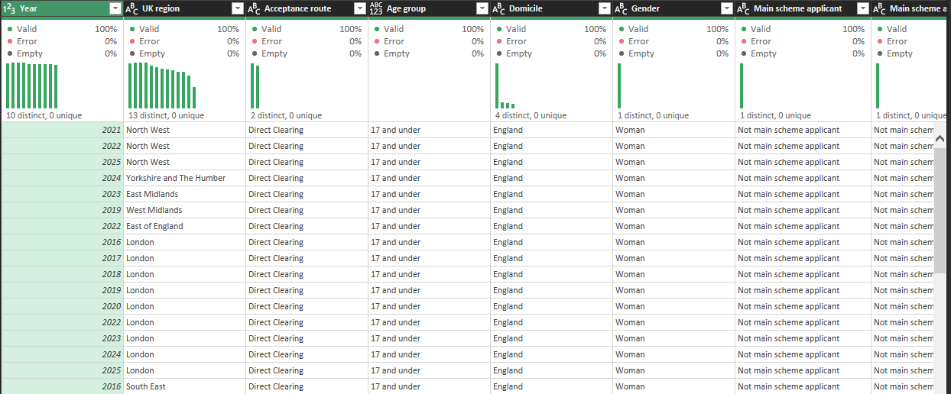
(Figure one – columns)

The UK Government Data Quality Framework was used to inspect the data quality, checking for completeness, uniqueness, validity, and timeliness (Government Data Quality Hub, 2020).

All rows had 100% valid values, with no null values. If there were null values, these would either be replaced with 0 or removed, depending on the impact and context. For example if the ‘Accepted applicants’ column had a value of 0, this would be retained as it contains a useful value, and if it were null it would be replaced with 0 to retain the value. However if the ‘UK region’ column was empty, the row would be removed as this has no further use for the dataset.

The column ‘Main scheme application’ was the same as ‘Main scheme applicant’ was removed, leaving 8 columns.

To enable quantitative analysis, an index column was added per each string column, to switch out the values into an integer, for easier analysis later. For example, see the ‘UK region’ index column in figure two:

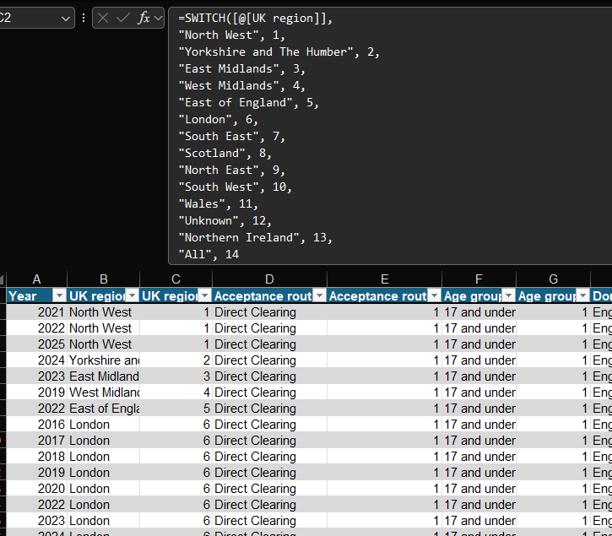
(Figure two – SWITCH formula)

The corresponding values have been documented and filed.

Next, data was copied into a csv file for exploratory data analysis (EDA), which is explained in the ‘Data Analytics’ section.

For visualisation, data was imported into Power BI through the Excel workbook. Data was first checked, however since it has already been transformed in Excel, no work was required. However, when loaded, there were 108,464 errors, shown in figure three:
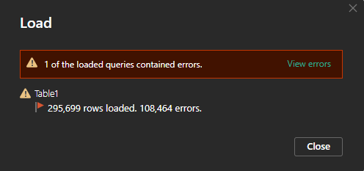
(Figure three – errors)

The error was with ‘Age group index’. Therefore, the column was deleted as it can be replaced through Power BI.

To ensure values can be filtered appropriately, records containing ‘All’ were deleted, as these could have an impact on the values displayed and filtered – for example, when ‘Sum of accepted applicants’ was used in a card, the card displayed a value of 600 billion. To enable the values to still be filtered, the ‘All’ values were deleted, as they are duplicated.

Data Analytics

The primary question asked for this project is: “how can region, year, age and gender impact university attendance?”, with an aim to use k-mode clustering to establish groups of applicants. Given the question, clustering was chosen as an analytics technique to segment applicants and gauge if there are any trends, therefore providing a better answer to the question. As the data is categoric, other analysis techniques such as linear regression or time series analysis would not work, and logistic regression would not be appropriate in this case as all applicants have already accepted, so there would be no Boolean outcome to predict.

Data was initially analysed in python prior to extracting into Power BI, to review whether k-mode clustering is suitable for this dataset and can be presented through power BI. K-mode clustering was used as data is nominal (Geeks for Geeks, 2026).

Data was first imported into Jupyter and checked to assess whether it has been imported correctly, highlighted in figure four:

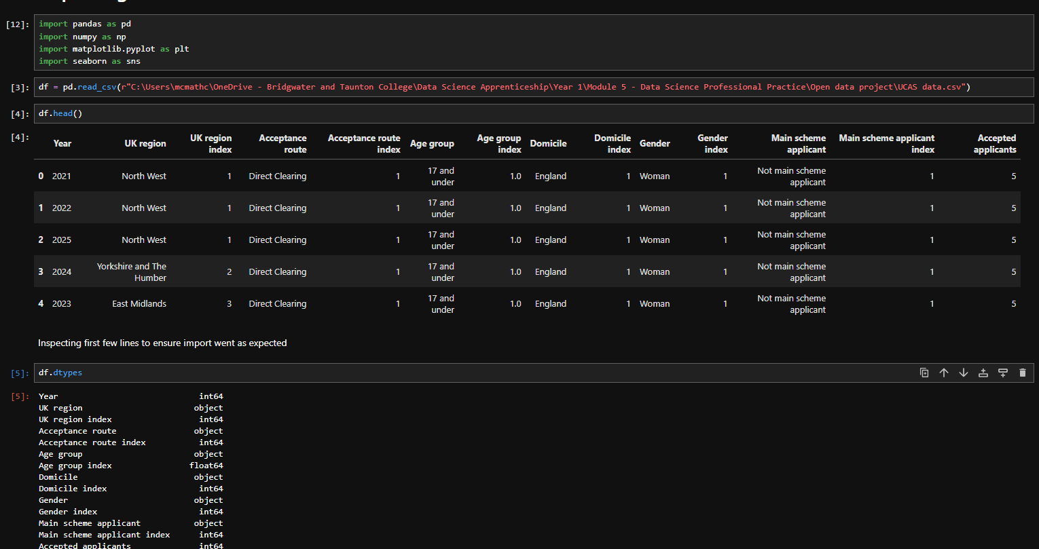
(Figure four – importing to Jupyter)

Next, EDA took place to explore any relationships between features:

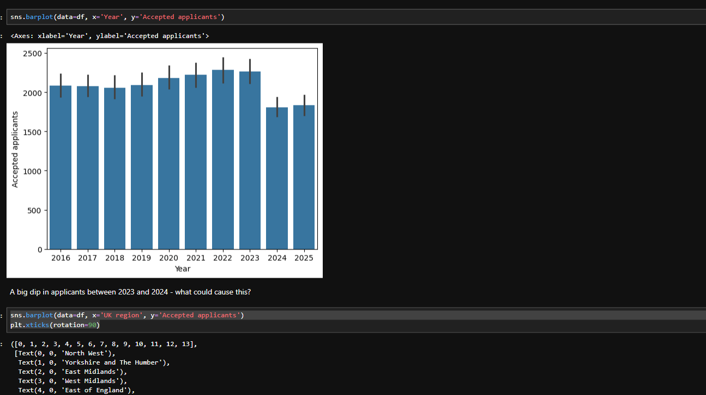
(Figure five – bar chart for university acceptances)

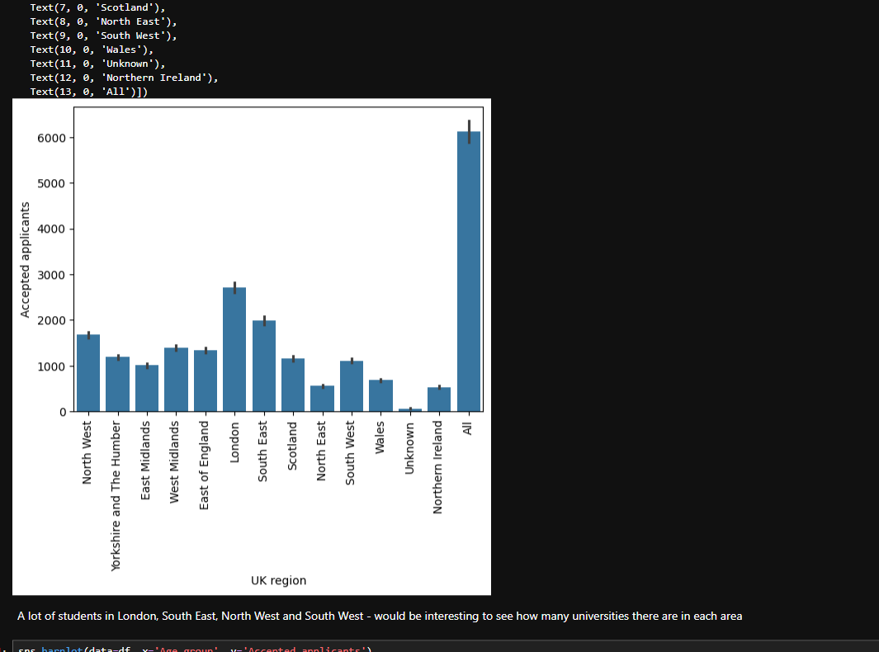
(Figure six – bar chart for acceptances across regions)

Then, K-Mode clustering took place to evaluate whether it is possible on this dataframe:

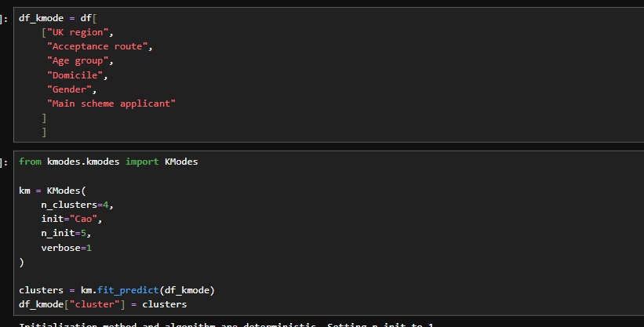
(Figure seven – K-mode clustering)

With the output being the following:
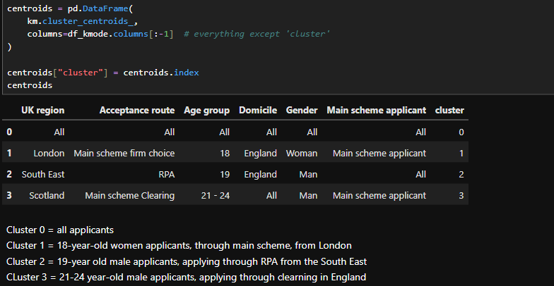
(Figure eight – K-Mode clustering output)

When the data was extracted into Power BI, unfortunately only k-means clustering works, as it only accepts discrete data.

Ethically, this data contains features which represent protected characteristics (GOV.UK, n.d.), therefore it is important to represent this correctly, and the results can be used to encourage demographics to apply to university. For example, the data highlighted that there was a higher proportion of women entering university than men, therefore measures can be put in place to encourage more men to attend university.

This data is also at risk of being biased – as it is sourced from UCAS, it does not cover all university applicants, therefore it is naturally biased to entrants that applied via UCAS. Additionally, the data is aggregated, which prevents it from being analysed at an individual level, and means it could mask specific attributes.

Data Visualisation & Dashboards

The data for this project has been presented in Power BI, to enable users to interact with the data and categorise as required. First, data was imported into Power BI using ‘Get data’, and linked this with the Excel workbook. With the engineering work already completed, the data did not require any further transformation once it was extracted into Power BI. The intended audience for this dashboard are analytical users within Higher Education – those seeking to identify trends within university entrants. When reviewing the data, it transpires that most entrants are from London, are aged 18 and are women. Figure nine shows the dashboard:

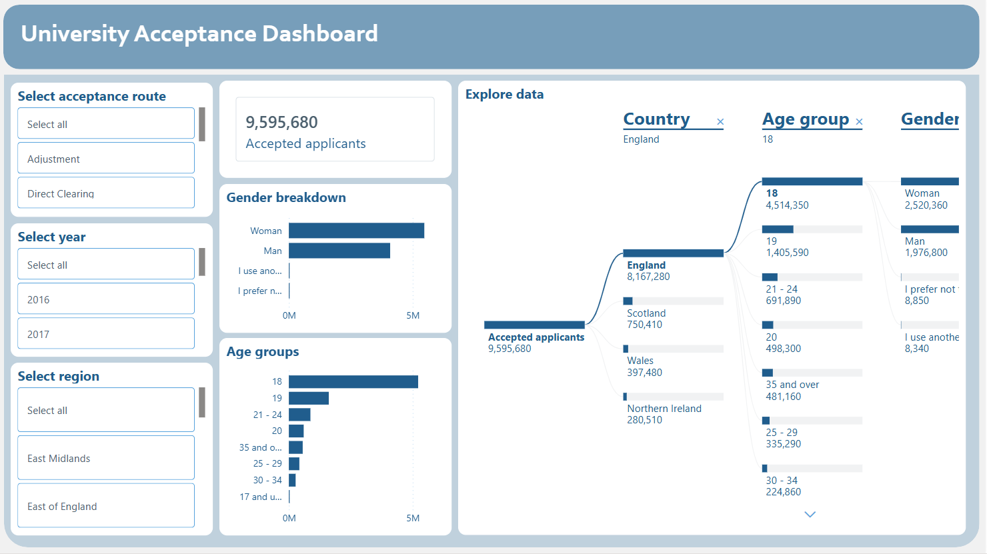
(Figure nine – Power BI dashboard)
On the dashboard, a calm and professional-looking theme was used. No default themes were suitable, so a theme online was used (wanajo38, 2023). This allows the information to be presented in a manner that is not overwhelming to the user, however still visually engaging.

Splicers on the left allow the user to filter the data as required. These splicers can be stacked, so a user can drill down into the year, region, and acceptance route required. As they can be stacked, the user can very specifically search for the number of accepted applicants, breaking this down into gender and age groups.

The user can also filter the data using the bar charts, for example if they only want to view one gender, they can filter the rest of the visuals by clicking on this. This also impacts the tree graph on the right, really allowing the user to be specific.

Initially, an Azure map was implemented, however this was unfortunately removed as the information was not being visualized as expected – the map was not recognising different locations as being within the UK, and was instead only recognising them in different countries, such as Zimbabwe. After adding a helper column with the value “United Kingdom”, and categorising this as a Country/Region, this unfortunately still did not work. In another attempt, the specific locations will be used to help prevent this.

Data visualisation best practices were reviewed and incorporated as necessary, for example minimising text and variables, and ensuring the graphs were familiar to the user.

Conclusion and recommendations

This project demonstrates that the categories do have an impact on university acceptance, particularly region, gender, and age, with most university entrants coming from London, being women and being aged 18. To build on the conclusion from this project, further work could be completed, such as reviewing the proportions of residents within an area and comparing the rates of entry within university for a better reference point between regions. Other features could be included, such as ethnicity and wage for the region, to gauge if these have an impact on university enrolment. The primary recommendation is to build on this work and develop a wider picture, prior to making recommendations to decision makers.

